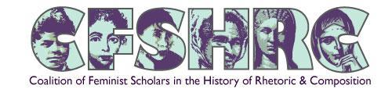

Coalition of Feminist Scholars in the History of Rhetoric and Composition
NANCY A. MYERS FEMINIST RESEARCH GRANT APPLICATION

Applicant Information

Name:
Phone:
Email:
Permanent Address:
Institutional Affiliation:
Major Areas of Interest:
Institutional Status:

Two Letters of Recommendation
Emailed separately

Recommender #1:

Recommender #2:

Application Questions

- Explain your proposed research project, including a timeline and your current progress on the project (Note: all projects will be considered, regardless of their current stage)

- Identify your primary objective for undertaking this research. Include, for example, the particular holdings where you intend to conduct research, or, for instance, the specific kinds of digital support necessary to complete the project, or the specific resources necessary for translation.

- Articulate the specific goals of the overall project and the specific funded experiences as well as the outcomes you hope to achieve.

- Discuss how your research relates to the mission of the Coalition of Feminist Scholars in the History of Rhetoric and Composition.

- Other funding sources

- Budget:

Applications should be submitted to Tarez Samra Graban (tarez.graban@gmail.com) by December 15, 2021

